

**MINI PROJECT**

**Airline Reservation System**

Submitted by:

Name: Shantanu Sharma

University Roll No.; 1900320100146

Submitted to:

**Department of Computer Science & Engineering**

ABES ENGINEERING COLLEGE GHAZIABAD

**Table of Contents**

|  |  |
| --- | --- |
| *Content* | *Page No.* |
| Acknowledgments | 3 |
| Declaration | 4 |
| Tools and technology | 5 |
| Introduction | 6 |
| Survey | 7 |
| Design | 9 |
| pseudo code | 11 |
| Implementation | 16 |
| Snapshots | 21 |
| Conclusion | 29 |
| Result and discussion | 30 |
| References | 31 |
|  |  |
|  |  |
|  |  |
|  |  |

**Acknowledgments**

Firstly, Thank You sir for your guidance. Secondly, I would like to thank my college ABES under whose roof I have studied and completed my my project, without which i could not stand anywhere. Many thanks to my wonderful lecturer, **DR Santosh Kumar** for guiding me with clear and always gave constructive feedback. His involvement in this assignment to help me out in any issues with regarding to the coding and techniques to write this report resulted in to this beautifully presented work. However, I would like to thank my parents who have been consistently supporting me and acting as a backbone of my success. The list cannot be completed unless I say thanks to my friends who spent their important time for standing beside me whenever i needed help for my project or even just to cheer me up. They kept supporting me with lots of care, attention and skills**.**

**DECLARATION**

I hereby declare that the Report entitled ("IPL") is an authentic record of my own work as requirements of Mini Project during the period from 28/10/20 to 19/11/20 for the award of degree of B.Tech. (Computer Science & Engineering), ABES Engineering College, Ghaziabad, under the guidance of Mr.SANTOSH KUMAR.

**(Signature of student)**

**Date: 19/11/20 SHANTANU SHARMA**

**(1900320100146)**

**CHAPTER 1**

**Tools and technology used**

Originally, C language is developed from two previous languages, BCPL and B. BCPL which were developed in 1967 by Martin Richards as a language for wring operating systems and compilers. C was evolved from B by Dennis Ritchie at Bell Laboratories and it was implemented in 1972. It initially became widely known as the development language of the UNIX operating system. Lots of today’s leading operating systems are written in C and C++. C language is mostly hardware independent as it is possible to write C programs that are portable to most computers.

Why we use c language C has been used successfully for each kind of programming problem thinkable from operating systems to spreadsheets to expert systems - and efficient compilers are accessible for machines ranging in power from the Apple Macintosh to the Cray supercomputers. the largest measure of C's success appears to be based on strictly sensible considerations:

**CHAPTER 2**

**INTRODUCTION**

It is assumed that the program is Airline Reservation Systems:

A small airline has just purchased a computer for its new automated reservation system. The owner has asked to program the new system in C. It is required to write a program to assign seats on each flight of the airlines only place (capacity: 15 seats). The program should never assign a seat which is already assigned. If there’s no seat available, then print the message " the flight is full ".

After the flight is full and someone want to cancel the booking, it is displaying enter you’re the passport number you want to cancel it so after the passenger cancel it, the system directly free that place id someone want to book that seat.

Moreover, the system should bring a boarding pass indicating the persons' name, passport number and seat number as each seat is assigned, set the corresponding elements of array to 1 to indicate that seat is no longer available.

**Chapter 3**

**Survey**

Travel agencies and individual agents are going for top travel technology tools and mobile apps to engage and serve global customers.

They no longer follow the traditional process for bookiing flight deals offline. With the advancement of top travel technology and mobility solutions, agencies are using online flight booking systems, where in end customers and sub agencies can search and serve flight deals online.

That’s why , most of the travel startups, Non IATA and IATA agencies are going for the OTA model

**Pseudocode**

Begin

Declare Choice Repeat

repeat

display “welcome to our airlines”

display “Airline Seat Selection

1.Reservathion

2.Cancel

3.Dispaly layout

4.Exit

Enter your choice”

Accept choice

If (choice = 1)

Call R ()

Else

If (choice = 2)

Call C ()

Else

If (choice = 3)

Call D ()

Else

If (choice = 4)

Call E ()

Else

Print “Invalid choice”

End-If

End-If

End-If

End-If

Until (choice <> 4)

End

Function reservation ()

Declare passport number, name, num, email, contact number

Print “Enter your passport number”

Accept passport number

Print “Enter your name”

Accept name

Print “Enter your email “

Accept email

Print “Enter your contact number”

Accept contact number

IF (seats >15)

Print No Seats Available

ELSE

IF

(Seats <=15)

Print “registered successfully”

END-IF

END-IF

END-FOR

Return

Function Cancel ()

Declare Passport number

Print “Enter passport number to delete record”

Accept passport number

Do while (not end of records)

IF (passport = record _passport)

Delete record

Return

END-IF

Read next record

END-do

print

Return

Function Display layout ()

Do while (not end of records)

Display Record

Read next record

End -do

Return

**Implementation**

**(Header file )**

#include<stdio.h> (is a standard output function)

#include<stdlib.h> (Console Input Output)

#include<conio.h>

#include<string.h>

#include<Windows.h>

struct mufti_airline (Structures are used to represent a record)

{

char passport[6]; (Declaring)

char name[15];

int seat_num;

char email[15];

struct mufti_airline *following;

}

*begin, *stream;

struct mufti_airline *dummy;

void main()

{

void reserve(int x), cancel(), display(), savefile(); //function prototypes

int choice;

begin = stream = NULL; //initialize the struct pointers to NULL

int num = 1;

do

{

(Printing the menu )

printf("\n\n\t\t ********************************************************************");

printf("\n\t\t welcome to mufti's airline system ");

printf("\n\t\t *******************************************************************");

printf("\n\n\n\t\t Please enter your choice from below (1-4):");

printf("\n\n\t\t 1. Reservation");

printf("\n\n\t\t 2. Cancel");

printf("\n\n\t\t 3. DISPLAY RECORDS");

printf("\n\n\t\t 4. EXIT");

printf("\n\n\t\t feel free to ask us");

printf("\n\n\t\t Enter your choose ");

scanf("%d", &choice); fflush(stdin);

system("cls"); (cls" is a command on some operating systems that clears the screen

switch (choice) (Each value is called a case, and the variable being switched on is checked for each switch case)

{

case 1:

reserve(num);

num++; (to increment the seats by

adding 1 every time)

break; (we find the answer do not need to

test it anymore)

case 2:

cancel();

break;

case 3:

display();

break;

case 4:

{

savefile();

break;

}

Default: (every switch case has to have default after 4 just stop it is invalid choice)

printf("\n\n\t SORRY INVALID CHOICE!");

printf("\n\n\t PLEASE CHOOSE FROM 1-4");

printf("\n\n\t Do not forget to chose from 1-4");

}

getch(); (It forces to wait the output to stay on screen

until any key pressed from keyboard)

} while (choice != 4); (coz we have 4 cases so when if it more

than 4 give default)

}

void details()

{ (it is asking the user to input the details)

printf("\n\t Enter your passport number:");

gets(stream->passport); fflush(stdin); //reads a line from stdin and stores it into the string pointed

printf("\n\t Enter your name:");

gets(stream->name); fflush(stdin);

printf("\n\t Enter your email address:");

gets(stream->email); fflush(stdin);

}

void details();

void reserve(int x) (int x the reservation part is only for 15 seats so I use x instead of 15 because if I want to change the seat number I will change only x)

{

stream = begin; (this is for first user want to register)

if (begin == NULL)

{

// first user

begin = stream = (struct mufti_airline*)malloc(sizeof(struct mufti_airline));

(memory allocation/ allocates the requested memory and returns a pointer to it)

details();

stream->following = NULL; (checking if the next node is empty book it )

printf("\n\t Seat booking successful!");

printf("\n\t your seat number is: Seat A-%d", x);

stream->seat_num = x; (same as I mentioned up x for seats number up to 15 seats )

return; (go back)

}

else if (x > 15) // FULL SEATS

{

printf("\n\t\t Seat Full.");

return;

}

else

{ ( it is registering the next users )

// next user

while (stream->following)

stream = stream->following;

stream->following = (struct mufti_airline *)malloc(sizeof(struct mufti_airline));

stream = stream->following;

details();

stream->following = NULL;

printf("\n\t Seat booking succesful!");

printf("\n\t your seat number is: Seat A-%d", x);

stream->seat_num = x;

return;

}

}

void savefile()

{

FILE *fpointer = fopen("mufti records", "w");

(where I store the

records in mufti record file)(opening the file)

if (!fpointer)

{

printf("\n Error in opening file!");

return;

Sleep(800); (delays program execution for a given number of seconds)

}

stream = begin;

while (stream)

{

fprintf(fpointer, "%-6s", stream->passport);

fprintf(fpointer, "%-15s", stream->name);

fprintf(fpointer, "%-15s", stream->email);

stream = stream->following;

}

printf("\n\n\t Details have been saved to a file (mufti records)");

fclose(fpointer); (closing the file)

}

void display() (it is displaying the all the records that I registered)

{

stream = begin;

while (stream)

{

printf("\n\n Passport Number : %-6s", stream->passport);

printf("\n name : %-15s", stream->name);

printf("\n email address: %-15s", stream->email);

printf("\n Seat number: A-%d", stream->seat_num);

printf("\n\n++*=====================================================*++");

stream = stream->following; (it is displaying one by one up to 15 seats)

}

}

void cancel()

{

stream = begin; ( deleting the first user)

system("cls");

char passport[6];

printf("\n\n Enter passort number to delete record?:"); (asking for the passport you want to delete)

gets(passport); fflush(stdin);

if (strcmp(begin->passport, passport) == 0)

{

dummy = begin;

begin = begin->following;

free(dummy); ( it is freeing the place)

printf(" booking has been deleted");

Sleep(800);

return;

}

while (stream->following) ( deleting the other records)

{

if (strcmp(stream->following->passport, passport) == 0)

{

dummy = stream->following;

stream->following = stream->following->following;

free(dummy);

printf("has been deleted ");

getch();

Sleep(800);

return;

}

stream = stream->following;

}

printf("passport number is wrong please check your passport");

(if user enter wrong passport number)

}

// ************************************GOOD LUCK*********************************

**CHAPTER 4**

**Snapshots**

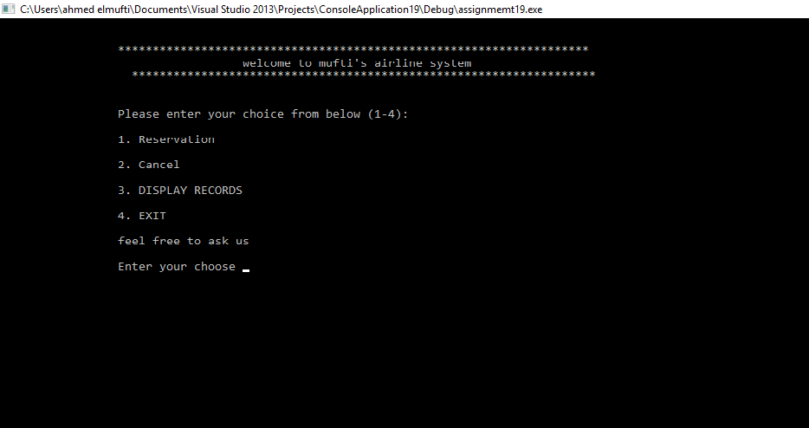

Main Menu interface

When the program is executed, the user will be directed to the main menu interface. The program is introduced with a few lines of texts. Then four selections are made for the user as the user can choose to reserve, cancel, display or exit the program.

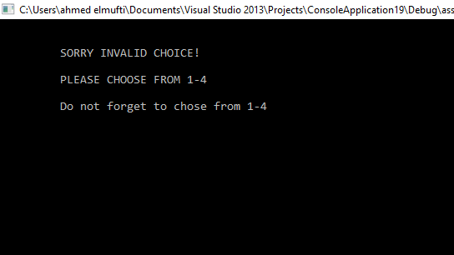

Invalid value entered (main menu)

. If the user accidentally enters an invalid input, an interface will be shown to notify the user to choose again and it notify the user again to enter from 1-4.

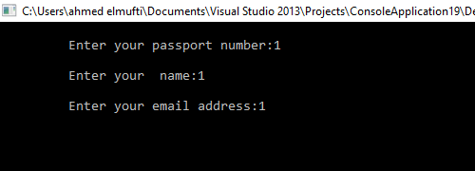

reservation function

The program is asking the user to enter passport number, name, and the email address to reserve a seat for the user and the seat cannot be book for anyone else.

Figure 10: Invalid Command (LED Selection Menu)

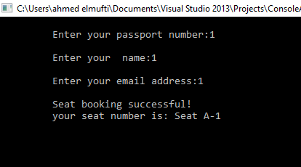

Figure the seat has successfully booked

As shown in the interface the seat reservation has been booked successfully, after the user has entered the details.

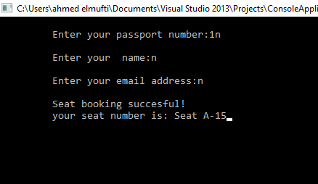

15 is the maximum seats number the program could not book any more seat

After registering 15 users in the system now the flight supposed to be full and cannot except anymore.

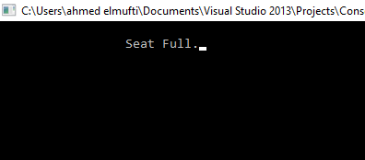

Figure it is displaying the no more seat available that cannot book any seat

The system will pop out to notify the user that there’s no seat available, the flight contains only 15 seat after that it is displaying it is full sorry we cannot register anymore.

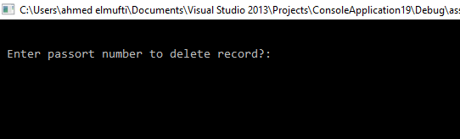

cancel function

After the passenger entered 3 and want to cancel the record, after that, the program requires the user to enter which passport number to delete it. For example, that mufti registered the seat in the flight and he wants to cancel it.

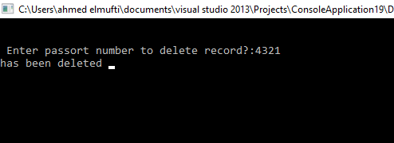

The system asking mufti to enter his passport number to cancel it from the system without any problems and in efficient way. After mufti entered his passport number the system pop in your record has been deleted from the system.

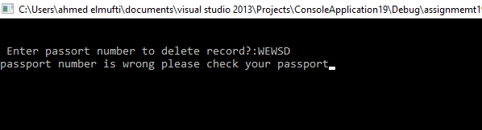

If mufti entered the wrong passport number by mistake the system pop in hey ahmed passport number is wrong, please check your passport number and enter it again.

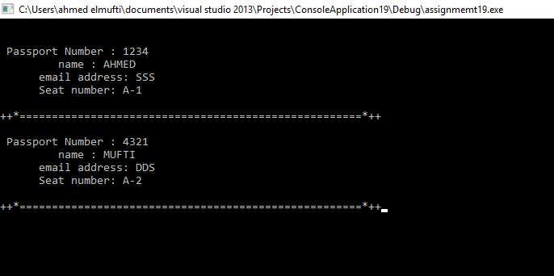

The interface is displaying all the users record that now you have two seats ahmed with his details and mufti with his details as well. There’s line between the users to make it clear to read and do not misunderstand it.

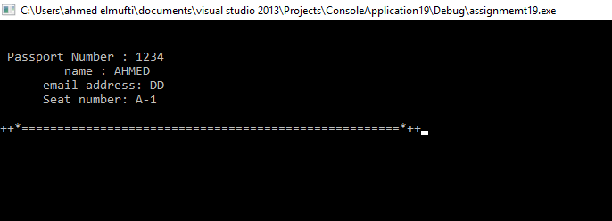 display function

After mufti cancel his seat from the system, the interface is showing that only ahmed in the system and mufti’s seat already deleted.

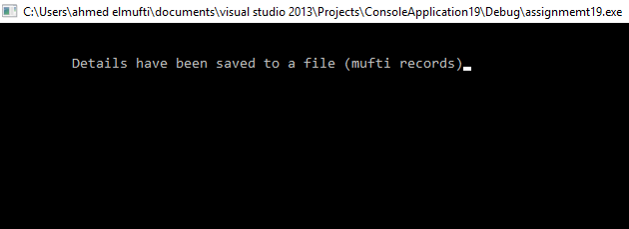

after entered 4 which is exit function, it is storing all the records into file with all the passenger’s details in mufti record.

The interface is showing the record in notepad which is the storing part and it is displaying ahmed and his details after mufti cancel his record.

**CHAPTER 5**

**Conclusion**

The Airline reservation system is designed for users to reserve a seat, cancel, display seat and exit the system. A formula is included in the function to calculate the seats are reserved. Pseudocode is written for some important codes. A few flow charts are also created for explaining the process of the Airline reservation system.

From this assignment, I have learnt to implement a few C concepts in the future projects such as functions, switch statement and do…while statement, arrays, pointers and structures in the program.

**CHAPTER 6**

**Result and discussion**

My airline reservation system project has been one of the rewarding experience I have had. I have learnt a lot of things in the entire course of my project. I have taken up both the front end and back end responsibilities. I had some difficulties with the coding part initially but my dedication and hard work helped me complete it. I have also improved my coding skills through this project.

On the whole , I would like to thank my committe members for guiding.

**References**

I took help from youtube , books like programming with C , guidance from my friends etc.

# References

Jenny's lectures from youtube

Anon., n.d. *Do...while loop in C.* [Online]   
Available at: https://www.tutorialspoint.com/cprogramming/c_do_while_loop.htm

Anon., n.d. *Linked list program in C.* [Online]   
Available at: https://www.tutorialspoint.com/data_structures_algorithms/linked_list_program_in_c.htm

Anon., n.d. *Pointers in C.* [Online]   
Available at: https://www.tutorialspoint.com/cprogramming/c_pointers.htm

Anon., n.d. *Strings in C.* [Online]   
Available at: https://www.tutorialspoint.com/cprogramming/c_strings.htm

Anon., n.d. *Switch statement in C.* [Online]   
Available at: https://www.tutorialspoint.com/cprogramming/switch_statement_in_c.html

GTCoding, 2015. *Create array dynamically in C using malloc.* [Online]   
Available at: https://www.youtube.com/watch?v=phovjaAVuFY

tutorialspoint, 2014. *C - basic introduction.* [Online]   
Available at: http://www.tutorialspoint.com/ansi_c/c_introduction.htm